AI FAQ ASSISTANT AI

A Mini project report

BACHELOR OF COMPUTER SCIENCE
(2024 – 2027)

Submitted by

THIRISHA.S VINITHA.V
222408439 222408442

DHANALAKSHMI.S GAYATHRI.J
222408412 222408417

Under the Guidance of
Mrs.Helen M.Sc., M.Phil.
Assistant Professor
Department of Computer Science


SOKA IKEDA COLLEGE OF ARTS AND SCIENCE FOR WOMEN,
MADHANANGKUPPAM, CHENNAI – 600 099.
Affiliated to the University of Madras, Chepauk, Chennai 600 005.

ABSTRACT:
- The AI FAQ Assistant is a secure, intelligent, and scalable REST API platform designed to simplify the process of creating, managing, searching, and accessing frequently asked questions. In many organizations, customer support teams receive a large number of repeated questions, making manual FAQ creation and maintenance time-consuming. This project provides an automated backend solution that reduces manual effort and helps users obtain relevant answers quickly and efficiently.

- The system is developed using Node.js and Express.js for building the RESTful API and MongoDB with Mongoose ODM for storing and managing user and FAQ data. The application follows a structured architecture that separates data management, business logic, and API routing, making the system easier to maintain and extend. It supports essential CRUD operations for creating, viewing, updating, and deleting FAQ records.

- Security is an important part of the system. JSON Web Token (JWT) authentication is used to protect private API endpoints and control authorized access, while bcrypt is used for secure password hashing. Schema validation through Mongoose helps maintain data consistency and prevents invalid information from being stored in the database. Centralized error handling provides standardized responses and improves the reliability of the application.

- The project also integrates Google Gemini AI using the Google Generative AI SDK to provide intelligent question answering and automatic FAQ content generation. Users can submit questions and receive AI-generated responses, while FAQ topics and content can be generated automatically. The system also supports semantic search, allowing users to find relevant FAQ information based on the meaning of their queries rather than relying only on exact keyword matches.

- Overall, the AI FAQ Assistant combines secure authentication, database management, RESTful API services, semantic search, and artificial intelligence into a single backend platform. It provides an efficient and user-friendly approach to FAQ management while offering a strong foundation for future enhancements such as advanced search, analytics, multilingual support, and improved AI capabilities.

CHAPTER | TITLE
1. | INTRODUCTION
2. | PROJECT OVERVIEW
3. | REQUIREMENTS
4. | PROJECT ARCHITECTURE
5. | ER DIAGRAM
6. | STRUCTURE MAPPING
7. | ROLES AND RESPONSIBILITIES
8. | USER FLOW
9. | MVC ARCHITECTURE PATTERN
10. | PROJECT SETUP AND CONFIGURATION
11. | BACKEND OVERVIEW
12. | API ROUTER INTERFACE ENDPOINT
13. | PROJECT EXECUTION
14. | OUTPUT SCREENSHOT
15. | CONCULSION

AI FAQ ASSISTANT AI

1.INTRODUCTION
- The ai FAQ assistant is a secure and intelligent rest api platform for faq creation, user authentication, and ai-powered content management. Built with node.js, express.js, and mongodb using mongoose odm, it uses jwt for authentication and bcrypt for password encryption. The system supports automated faq generation, semantic search, context parsing, and centralized error handling for secure and reliable operation.

2.PROJECT OVERVIEW:

Background
Priya, a customer support manager, faces difficulties managing repetitive inquiries, organizing faqs, and tracking customer trends.

Problem
- Time-consuming manual faq creation and updates.
- Difficulty with semantic search and quick query resolution.
- Lack of secure database permissions.
- Challenges in drafting accurate support answers.

Solution
The ai faq assistant provides a centralized and secure backend api for faq creation, categorization, database management, and ai-powered content generation.

Usage
- Authenticated users: create, update, and delete their own faq records using ai assistance.
- Public users: view published faqs and perform semantic searches.

Outcome
The system reduces manual effort, maintains data integrity through schema validation, secures user access with authentication, and enables fast faq discovery.

3.REQUIREMENTS:

SOFTWARE REQUIREMENTS
- Operating System: Windows 10/11, macOS, or Linux (supports cross-platform operations).
- Node.js (v18 or above): Runtime ecosystem running server logic and routing infrastructure.
- npm (v9 or above): Node package manager to control operational dependencies.
- Express.js (v4/v5 Ecosystem): Lightweight routing web framework to construct backend RESTful entry points.
- MongoDB / Mongoose ODM: Document NoSQL engine storing application users and curated data entities.
- Postman / ThunderClient: API verification toolkit to assert schema validation responses across administrative route shields.
- Code Editor: Visual Studio Code or similar IDE environment.

HARDWARE REQUIREMENTS
- Processor: Intel Core i5 (8th Gen or above) / AMD Ryzen 5 or equivalent.
- RAM: 8 GB minimum (16 GB recommended for concurrent instances of MongoDB processing layers).
- Storage: 1 GB of available disk workspace.

4.PROJECT ARCHITECTURE:

- The AI FAQ Assistant application exposes structured endpoints handled by a layered server architecture model. Incoming requests undergo filter processing before interacting with data services.



Components Definition
- Interface: API tools like Postman query distinct route paths to extract JSON entities.
- Express Server Gateway: Monitors network ports, maps explicit HTTP methods (GET, POST, PUT, DELETE), parses incoming JSON payloads, and handles CORS headers.
- Authentication Middleware: Extracts tokens from headers, validates user context signatures, and evaluates authorization thresholds for guarded resource paths.
- Granular Services (Logic Modules): Enforces isolated domain rules for user session life cycles and operational query modifications.
- Database Interface Layer: Mongoose translates operational application logic into performant native MongoDB queries.
- AI Flow (Service Integration): Connected to external AI models via Google Gemini SDK integrations, letting the controller layer offload complex question-answering tasks and automated topic generation workflows.

5.ENTITY-RELATIONSHIP (ER) DIAGRAM DESCRIPTION

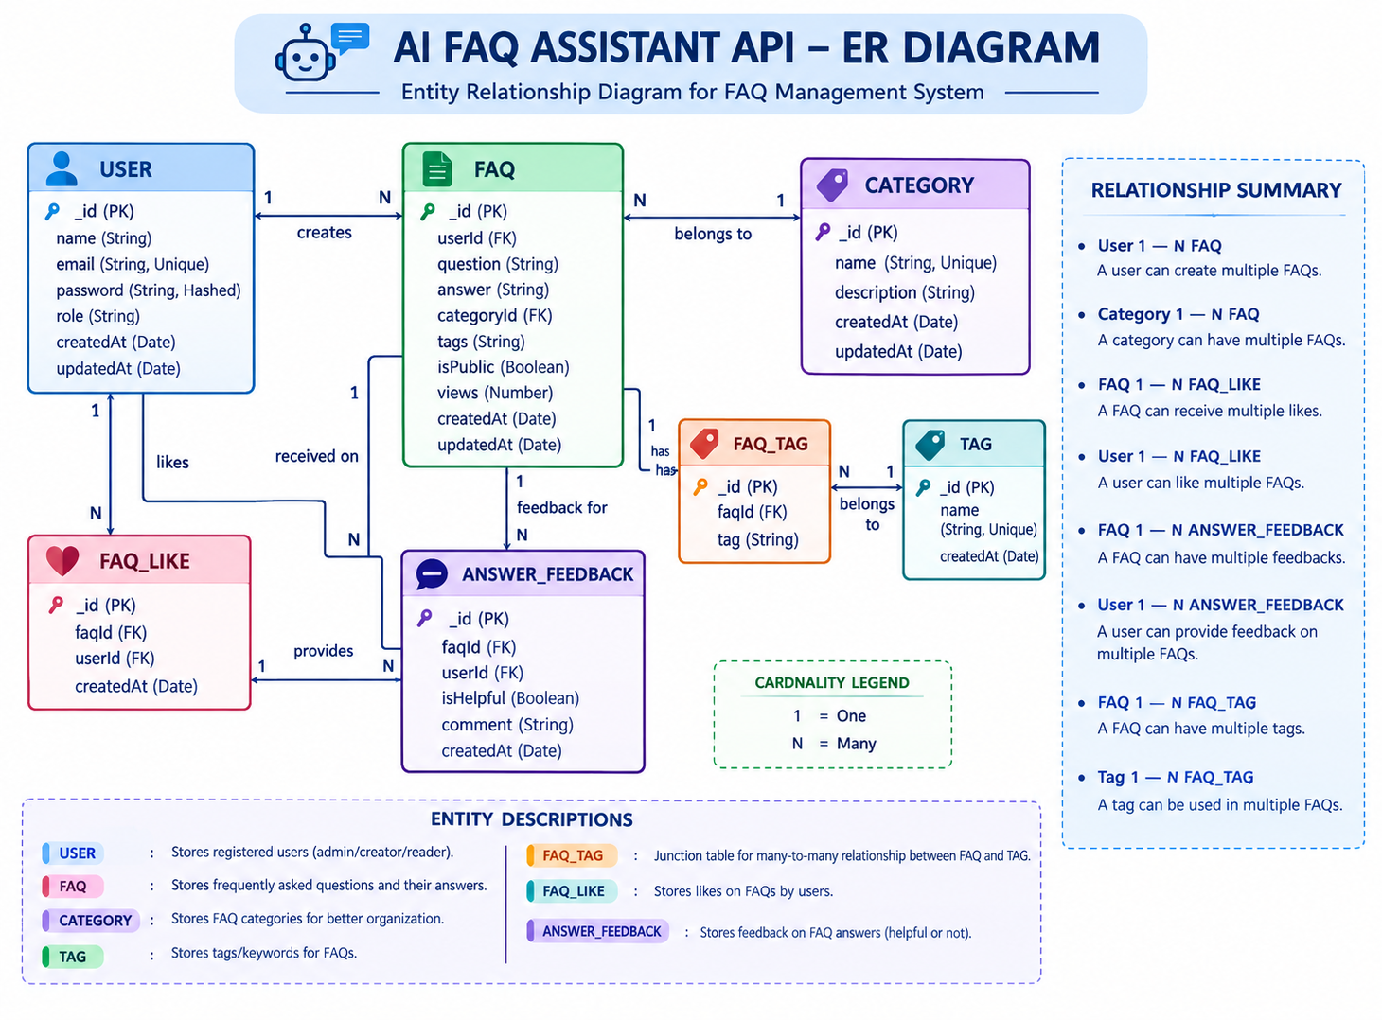
The backend database consists of multiple MongoDB collections connected through logical references to maintain user authentication, FAQ management, AI-generated content, and category or organisation.

User Entity
- _id – Primary Key
- name, email, password
- role
- createdAt, updatedAt

FAQ Entity
- _id – Primary Key
- question, answer, category
- createdBy – Foreign Key
- createdAt, updatedAt

AI Generation Entity
- topic
- generatedQuestion, generatedAnswer
- generatedCategory
- generatedAt

Category Entity
- categoryName
- description
- totalFAQs

6. KEY STRUCTURAL MAPPINGS

User → FAQ (One-to-Many):
A registered user can create and manage multiple FAQ records.
Category → FAQ (One-to-Many):
Each category can contain multiple FAQ documents.
User → AI Generated FAQ (One-to-Many):
A user can generate multiple AI-assisted FAQs, which may later be saved into the FAQ collection.
FAQ → Search Results (Logical Relationship):
Search queries retrieve matching FAQ documents using keyword and semantic matching.

KEY FEATURES
- JWT Authentication: Secures private API endpoints.
- AI FAQ Generation: Generates questions, answers, and topics using Gemini AI.
- Semantic Search: Enables fast FAQ searching.
- CRUD Operations: Create, read, update, and delete FAQs.
- Category Management: Organizes FAQs into categories.
- Password Encryption: Protects passwords using bcrypt.
- Error Handling: Provides standardized error responses.
- Schema Validation: Maintains data integrity.
- RESTful API: Provides scalable Express.js services.
- MongoDB Integration: Stores data efficiently using Mongoose.

7.ROLES AND RESPONSIBILITIES

Admin
- Manage all registered users.
- View, update, and delete any FAQ.
- Monitor AI-generated content.
- Manage FAQ categories.
- Access complete system functionality.

Content Creator
- Create new FAQs.
- Edit personal FAQ records.
- Delete owned FAQs.
- Generate FAQs using AI.
- Organize FAQs under categories.

Authenticated User
- View public FAQs.
- Search FAQs using keywords.
- Generate AI-assisted answers.
- Access personal profile information.

Public User
- View published FAQs.
- Search FAQs.
- Cannot create, edit, or delete FAQ records.
- No access to protected API endpoints.

- USER FLOW
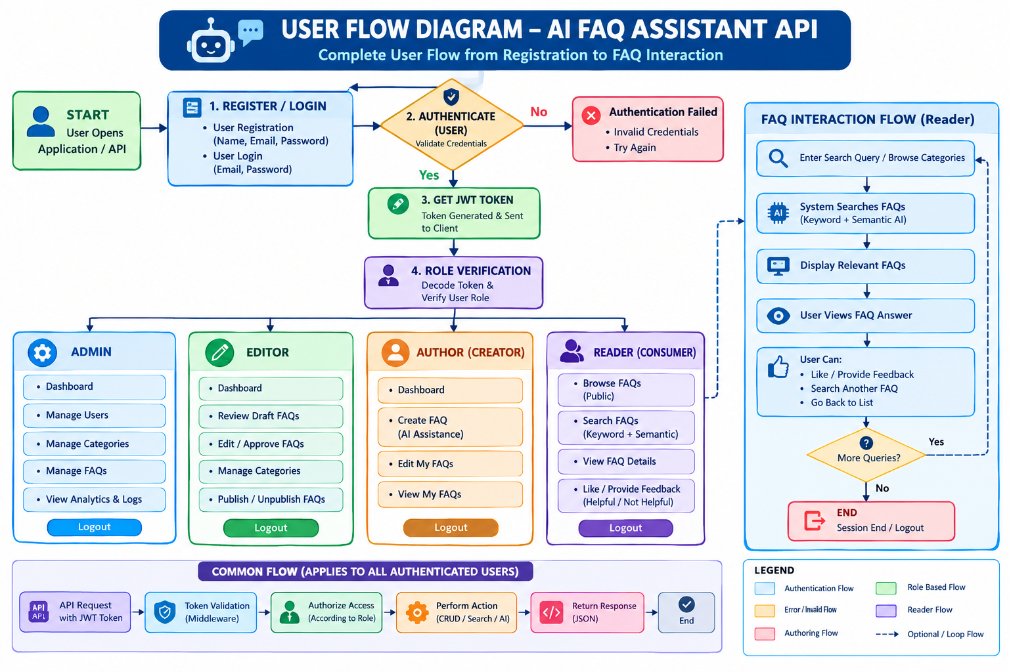

9.MVC ARCHITECTURE PATTERN:

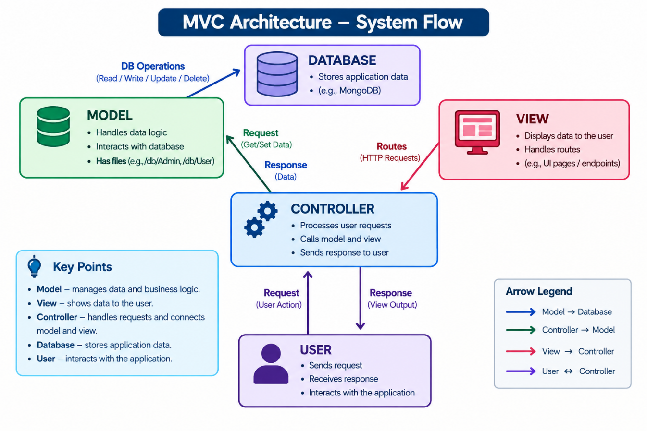
The system architecture structures its source configuration layers around the Model-View-Controller design pattern to completely decouple components:

System architecture
The system follows the model-view-controller (mvc) pattern to separate components.

Model layer
Defines mongoose schemas, field rules, and manages data stored in mongodb.

Controller layer
Processes requests, applies business logic, communicates with models/services, and returns json responses.

View layer
Since this is a backend api, the view is replaced by the api routing layer, which connects requests to the appropriate controllers.

10.PROJECT SETUP AND CONFIGURATION:

Creating Project Folder
- Create a new folder with your <project name>.
- Inside that folder, create a new subfolder named src.
- Now open that folder in VS Code.


Server Setup (npm init)
Open your root folder terminal in VS Code and run:
Bash
npm init -y
npm install express mongoose dotenv cors jsonwebtoken bcrypt @google/genai

File and Folder Structure Matrix

11. BACKEND OVERVIEW

1. Gateway server – src/server.js
The main server file loads environment variables, connects to the mongodb database, starts the express server, and listens on the configured port.


2. Gateway Express Setup (src/app.js)


3. Security Access Middleware (src/middleware/authmiddleware.js)
Intercepts incoming target queries, extracts transmission header authorization records, and validates token identity context claims:




Centralized Error Handler Middleware (src/middleware/errorMiddleware.js)

Database Configuration

Mongoose Schema Definitions

1. Identity Resource Document Schema (src/models/User.js)
Enforces profile field criteria validations and hooks password hashing steps prior to user document persistence:

2. FAQ Resource Document Schema (src/models/FAQ.js)
Models core properties and maps a distinct relational reference link back to the source creator document:

12. API ROUTER INTERFACE ENDPOINTS:

1. Public Authentication Operations (src/routes/authRoutes.js)




2. Protected FAQ Operations (src/routes/faqRoutes.js)

JavaScript

3. AI Automation Operations (src/routes/aiRoutes.js)


13. PROJECT EXECUTION:

Running the API
- Install Postman or Thunder Client:
Use either tool to send API requests and check the server responses.
- Start the Backend Server:
Open the VS Code terminal in your project folder and run:
npm run dev
If the server starts successfully, the API will be ready to receive requests.

API Testing – User Registration
The registration API allows a new user to create an account.
- Route: POST /api/auth/register
- Access: Public
- Purpose: Creates a new user account and stores the user details securely in MongoDB.
Request Body:
{
"name": "dhana",
"email": "dhana@gmail.com",
"password": "123456"
}
Explanation:
- name: The user's name.
- email: The user's unique email address.
- password: The user's login password, which should be securely hashed before database storage.
After sending the request through Postman or Thunder Client, the server validates the details, creates the user account, and returns an appropriate response.

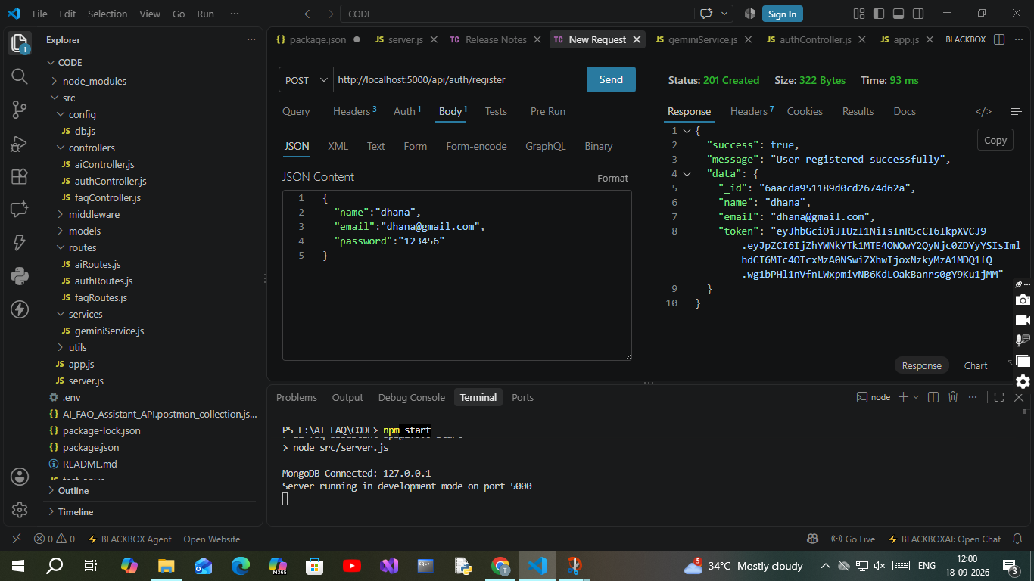

2. Profile Login Verification Query
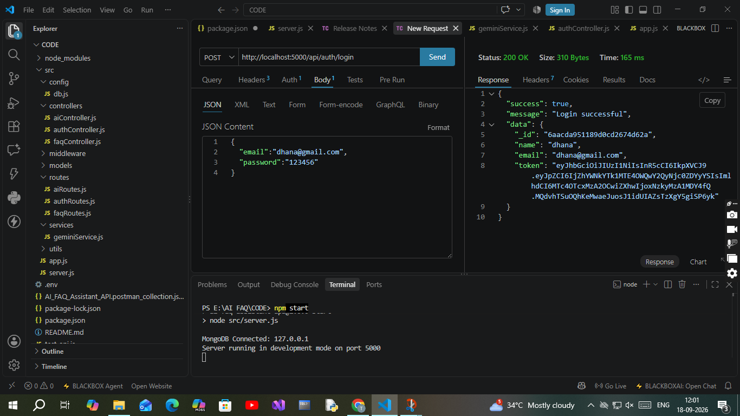
- Route: POST /api/auth/login
- Access: Public
- Payload Request Body JSON:
JSON

{
"email": "dhana@gmail.com",
"password": "123456"

}

API Testing – User Profile

The Profile API allows an authenticated user to view and manage their personal profile details.
- Route: GET /api/users/profile
- Access: Private / Authenticated
- Purpose: Retrieves the profile information of the currently logged-in user.
Request Header:
Authorization: Bearer <JWT_TOKEN>
Explanation:
- JWT Token: Verifies the user's identity.
- User Details: Returns information such as name and email.
- Authentication: Only logged-in users can access the profile.
- Database: Profile details are retrieved from MongoDB through Mongoose.
After sending the request, the server validates the JWT token, identifies the user, retrieves the profile data, and returns the details as a JSON response.
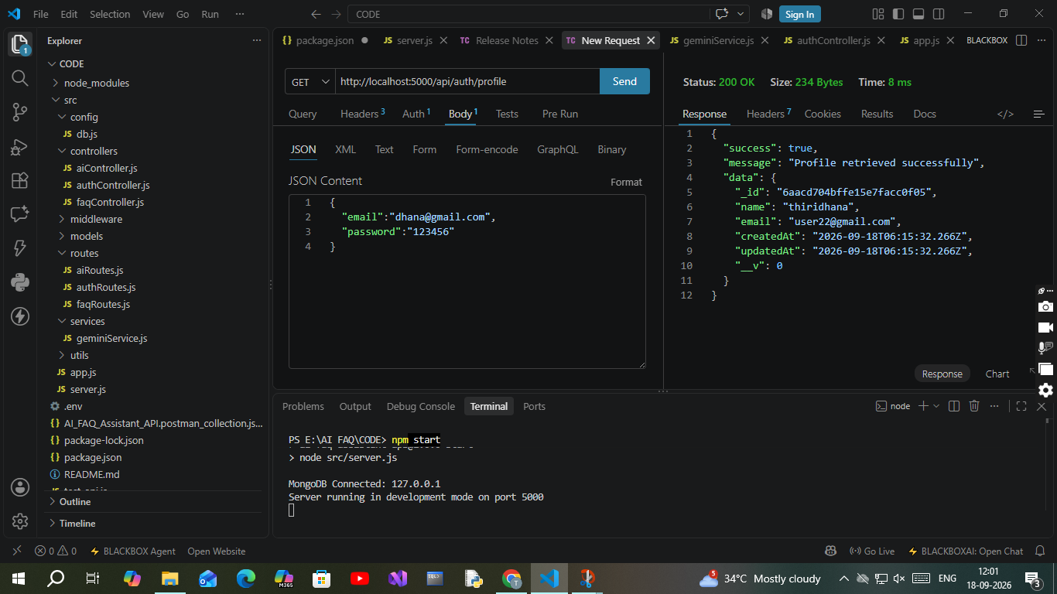

OUTPUT SCREENSHOT:

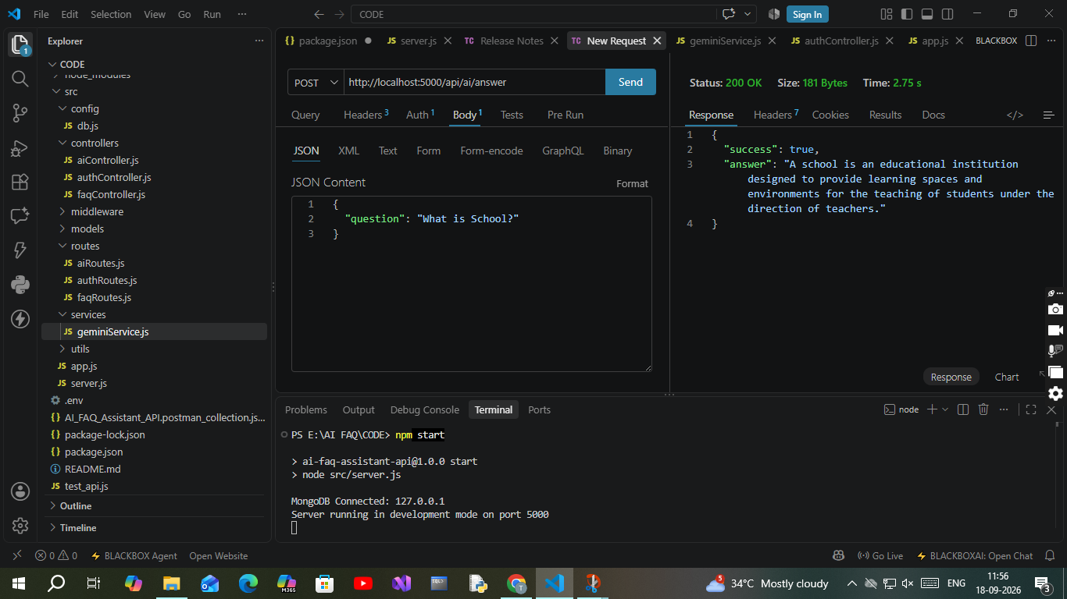
The AI Assistant successfully processes the user’s question and returns an AI-generated answer.
Request:
{
"question": "What is School?"
}
Output:
{
"success": true,
"answer": "A school is an educational institution designed to provide learning spaces and environments for the teaching of students under the direction of teachers."
}
Result:
- Status: 200 OK
- Success: true
- Answer: AI-generated response to the user’s question.
- The response is returned in JSON format.

15. CONCLUSION
The AI FAQ Assistant API provides a secure and intelligent platform for managing FAQs and generating AI-powered answers. Using Node.js, Express.js, MongoDB, JWT, bcrypt, and Google Gemini, the system supports authentication, FAQ management, semantic search, and AI-based question answering. Overall, it provides a reliable, scalable, and efficient backend solution for modern FAQ management.

Demo video: https://drive.google.com/file/d/1xspKJdfX0dzbOuFuBfmKJwz_XAbv1im9/view?usp=drivesdk
Code: https://drive.google.com/drive/folders/1dwWEsK-Dzsl61l6RkETUndcjlyr_ie8n

